Customer Shopping Behavior Analysis
📊 An End-to-End Data Analytics Project
Prepared by: Hriday Halder
Tools: Python (Pandas), PostgreSQL, SQL, Interactive Dashboard
Dataset: customer_shopping_behavior.csv

1. Project Overview
How do customers shop?
Who spends more?
Do discounts really increase revenue?
This project answers these questions by analyzing customer shopping behavior using real transactional data. The analysis follows a complete data analytics pipeline — from raw data cleaning to SQL-based business insights, ending with an interactive dashboard designed for decision-makers.

2. Project Goals (What This Analysis Tries to Answer)
This project was designed to:
- Understand customer purchasing behavior
- Identify high-value customer segments
- Measure the impact of discounts and subscriptions
- Analyze product performance and customer satisfaction
- Present insights in an interactive, easy-to-understand format

3. Dataset Understanding
Before analysis, it was important to understand what the data represents.
The dataset includes:
- 👤 Customer demographics (Age, Gender)
- 🛍️ Purchase behavior (Purchase Amount, Frequency)
- 📦 Product details (Category, Item Purchased)
- 💸 Discount & promotion usage
- 🚚 Shipping type
- ⭐ Customer review ratings
- 🔁 Previous purchase history
This combination allows both behavioral and financial analysis.

4. Data Preparation & Feature Engineering (Python)

4.1 Initial Exploration
The dataset was explored to:
- Understand data structure and size
- Identify missing values
- Review summary statistics
This step ensured that issues were addressed before analysis.

4.2 Handling Missing Values (Smart Imputation)
🔍 Problem: Some review ratings were missing
✅ Solution: Missing review ratings were filled using the median rating within each product category
👉 This preserves category-level customer sentiment and avoids skewed results.

4.3 Data Standardization
To ensure consistency and SQL compatibility:
- Column names were converted to lowercase
- Spaces were replaced with underscores
- Purchase amount column was renamed for clarity
This made the dataset clean, readable, and database-ready.

4.4 Feature Engineering (Making the Data More Insightful)

🧑‍🤝‍🧑 Age Group Segmentation
Customers were grouped into:
- Young Adult
- Adult
- Middle Age
- Senior
📌 This enables age-based revenue and spending analysis.

⏱️ Purchase Frequency Conversion
Purchase frequency labels (Weekly, Monthly, etc.) were converted into numeric day values, allowing quantitative comparison across customers.

💸 Discount & Promotion Optimization
It was observed that:
- discount_applied and promo_code_used carried identical information
➡️ The redundant column was removed to simplify analysis and improve data quality.

5. Database Integration (PostgreSQL)
Once cleaned, the data was loaded into a PostgreSQL database:
- Database: customer_behavior
- Table: customer
This allowed:
- Fast querying
- Use of advanced SQL (CTEs & window functions)
- Easy connection to dashboard tools

6. Business Questions & SQL Insights
Each SQL query was designed to answer a real business question.
📌 SQL output screenshots are included alongside each question.

Q1. Who Generates More Revenue — Male or Female Customers?

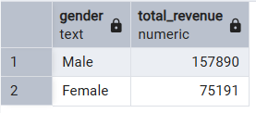
👉 Helps target gender-based marketing strategies.

Q2. Do Discount Users Still Spend More Than Average?

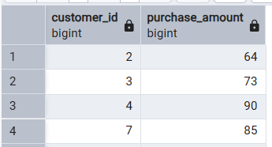
👉 Identifies high-value customers even when discounts are applied.

Q3. Which Products Have the Highest Customer Satisfaction?
👉 Based on average review ratings.
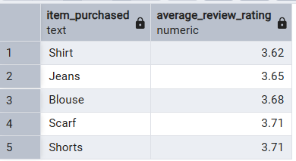

Q4. Does Shipping Type Affect Customer Spending?

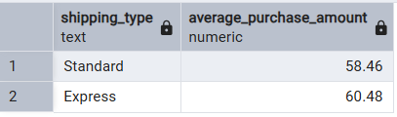
👉 Compares average purchase amount for Standard vs Express shipping.

Q5. Do Subscribers Spend More Than Non-Subscribers?

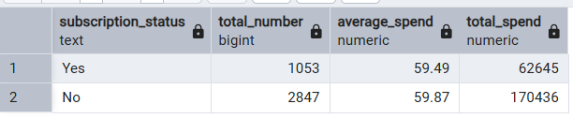
👉 Evaluates the financial value of subscription programs.

Q6. Which Products Depend Most on Discounts?

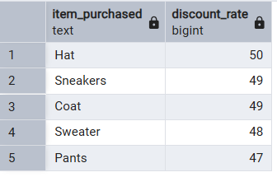
👉 Helps optimize discount strategies.

Q7. Customer Segmentation by Loyalty
Customers were classified as:
- New
- Returning
- Loyal
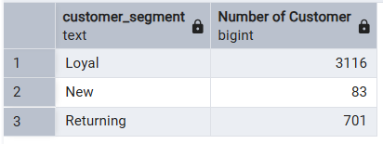
👉 Helps understand customer lifecycle and retention.

Q8. Top 3 Best-Selling Products in Each Category

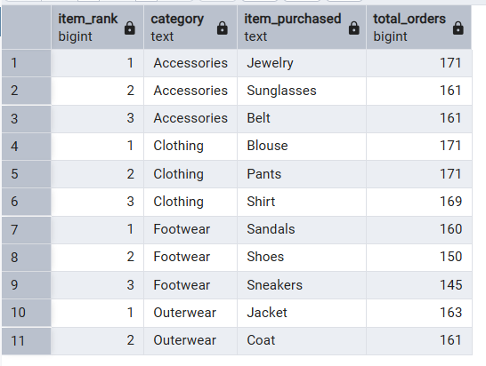
👉 Identifies category leaders using window functions.

Q9. Are Repeat Buyers More Likely to Subscribe?

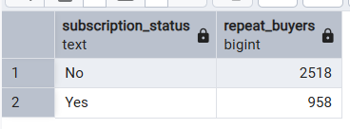
👉 Connects customer loyalty with subscription behavior.

Q10. Which Age Group Contributes Most to Revenue?

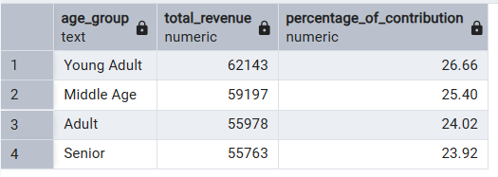
👉 Shows revenue share and percentage contribution by age group.

7. Interactive Dashboard Experience
An interactive dashboard was built to bring the analysis to life.

🔹 Dashboard Features:
- Revenue breakdown by gender & age group
- Product performance (sales & ratings)
- Discount usage trends
- Subscriber vs non-subscriber comparison
- Category-wise product insights
🎯 Users can:
- Apply filters
- Compare segments
- Explore trends visually
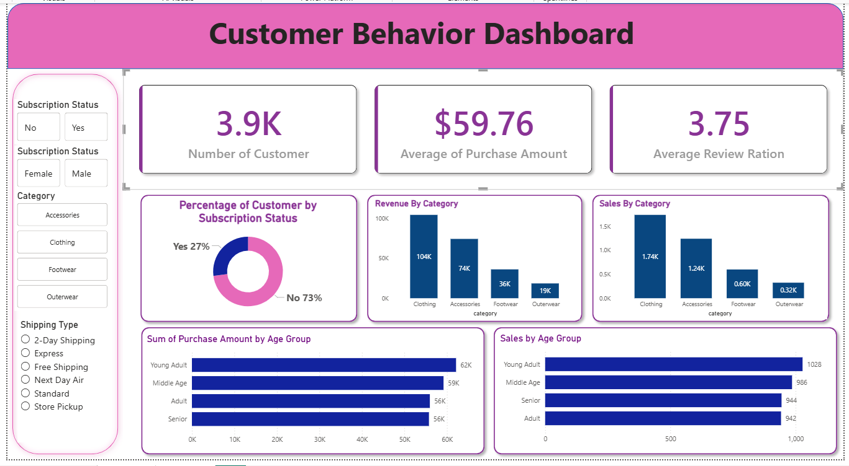

8. Key Insights & Observations
✨ Key takeaways from the analysis:
- Certain age groups contribute a significantly higher share of revenue
- Subscribers generally spend more on average
- Loyal customers generate strong revenue despite smaller numbers
- Discounts drive volume but not always higher value
- Express shipping customers tend to spend more per purchase

9. Business Impact
This analysis can help businesses:
- Improve targeted marketing campaigns
- Optimize discount strategies
- Enhance customer retention programs
- Identify high-performing products
- Make data-driven pricing and shipping decisions

10. Conclusion
This project demonstrates a complete data analytics workflow, combining:
- Python-based data preparation
- SQL-driven business analysis
- Database integration
- Interactive dashboard storytelling
The project showcases strong analytical, technical, and business-thinking skills, making it suitable for Data Analyst and BI Analyst roles.

